LAB 7
Constraints: Multiple Clocks and Exceptions

OUTLINE
I. Task 2: Constrain Parallel I/O Paths Separately
II. Task 3: Constrain a Multicycle Path

Design Schematic
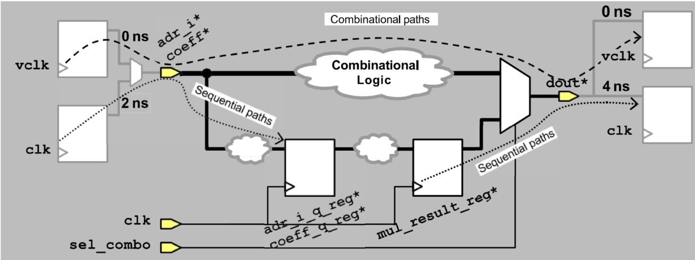

I. Task 2: Constrain Parallel I/O Paths Separately
DESIGN SPECIFICATION | COMMAND AND  COMMAND EXPLANATION
1. The combinational paths must have a maximum delay of 6 ns. Start by creating a 6 ns virtual clock vclk, along with input and output delays with respect to vclk that are set to 0 ns.  Remember that the input delay constraint should be applied to the ports coeff* and adr_i*. | Command:  create_clock -name vclk -period 6  set_input_delay 0 -add_delay -clock vclk [get_ports {adr_i* coeff*}]  set_output_delay 0 -add_delay -clock vclk [get_ports dout*]  Explantion Command 1:  create_clock -name vclk -period 6  + create_clock -name vclk -period 6 defines a virtual clock named vclk with a 6 ns period.  + This clock is not physically connected to any input port; it represents an external environment used to model combinational delay constraints.  Explantion Command 2:  set_input_delay 0 -add_delay -clock vclk [get_ports {adr_i* coeff*}]  + set_input_delay 0 -clock vclk specifies that data arriving at the input ports has 0 ns delay relative to the active edge of vclk.  + -add_delay ensures that existing delay constraints if defined before, will be preserved and not overwritten.  + [get_ports {coeff* adr_i*}] selects the input ports that use this delay specification.  Explantion Command 3:  set_output_delay 0 -add_delay -clock vclk [get_ports dout*]  + this command will applies a 0 ns output delay relative to the same virtual clock, maintain timing consistency between input and output port.  + [get_ports dout*] selects the output ports that use this delay specification.  + These commands together define a maximum cobinational delay of 6 ns between the input and output ports, without affect the actual design clock domain.
3. The clocks clk and vclk should not interact. Apply a logically exclusive clock group constraint (or two false path constraints, if you prefer) to disable timing analysis between these clocks. | Maybe using 2 command as follow:  Command 1:  set_false_path -from [get_clocks clk] -to [get_clocks vclk]  set_false_path -from [get_clocks vclk] -to [get_clocks clk]  Explantion 1:  + set_false_path used to remove timing constraints from particular path. In this case set_false_path used to set for path from clock clk to clock vclk and vice versa.  + Help tool can optimize runtime when perform analyze design.  + These constraint prevent false timing paths between independent clock domain, ensuring that cross-domain timing violations are not reported.  Command 2:  set_clock_groups -logical_exclusive -group clk -group vclk  Explantion 2:  + This command will tell for DC that the two clock domains are mutually exclusive, meaning that the two clock domain are mutually exclusive  + -group clk -group vclk separates the two clocks into distinct logical groups.
6. As the final step, disable timing analysis from clk to clk through the combinational logic using the false path command. | Command:  set_false_path -from [get_clocks clk] \  -through [get_ports {adr_i* coeff*}] \  -through [get_ports dout*] \  -to [get_clocks clk]  Explantion:  + set_false_path removes specific timing paths from analysis.  + -from [get_clocks clk] defines the starting point of the timing path as the main clock domain.  + through [get_ports {adr_i* coeff*}] -through [get_ports dout*] directs DC to ignore timing propagation through all intermediate input and output ports.  + -to [get_clocks clk] defines the destination clock domain as the same clk.  + This command disables analysis of clk → combinational → clk paths, which are not physically meaningful.  + It helps to simplify the timing reports and remove unrealistic timing checks.

II. Task 3: Constrain a Multicycle Path
DESIGN SPECIFICATION | COMMAND AND  COMMAND EXPLANATION
1. Apply a multicycle path constraint of 2 cycles for setup to all paths that end at the D pin of mul_result_reg* | Command:  set_multicycle_path -setup 2 -to [get_cells mul_result_reg*]  Explantion:  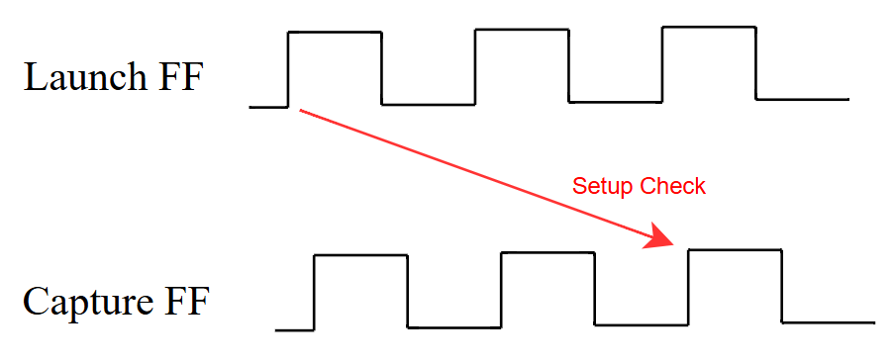  + Normally if we don’t set command set_multicycle_path  then setup check will check at positive edge after one cycle. But when set multicycle path with coefficient of option setup equal 2 then setup check will transfer setup check at positive edge of second cycle.  + set_multicycle_path defines paths that require more than one clock cycle to complete their setup timing.  + -setup 2 specifies that the path to the destination register (mul_result_reg*) can take two clock cycles for setup instead of the default one cycle.  + -to [get_cells mul_result_reg*] targets the D-pin of the destination register.
5. Complete the multicycle path constraint by including a constraint for hold. | Command:  set_multicycle_path -hold 1 -to [get_cells mul_result_reg*]  Explantion:  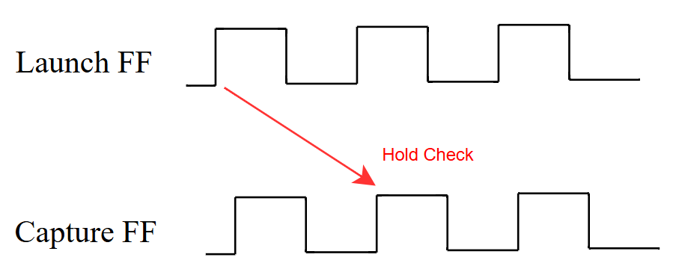  + -hold specifies that the constraint applies to hold-time checks.  + -hold 1 means that the hold check will occur one cycle earlier. Hold is checked like it due to we want checking data still stable after when the new data to capture filp-flop.  + This ensures proper alignment between the setup and hold relationships of a multicycle path.

